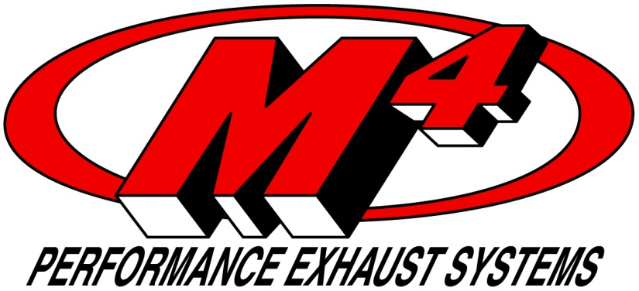

California Closed Course Competition Sale Form
The product that you are purchasing is designed and intended for close course competition use only. M4 Products are neither designed nor intended for use on Public Roads or Land. Such use is prohibited by Federal and State regulations.
By signing below, you acknowledge and understand that the M4 Exhaust product you are purchasing is for closed competition use only and that it will not be used on public roads or lands in violation of Federal and State law.
Name or Company_________________________________________________________
Address_________________________________________________________________
City____________________________ State_____________ Zip Code______________
Telephone #___________________________
Signature___________________________________ Date________________________
M4 Sales Order #______________________________(Filled in by M4)

2227 Joe Field Rd. Dallas, TX 75229 (972)481-9300 m4products@att.net Fax: (972) 488-2772

